IAS-PT-Y --------------- In-car information system Prototype

1. Overall

**Front:**

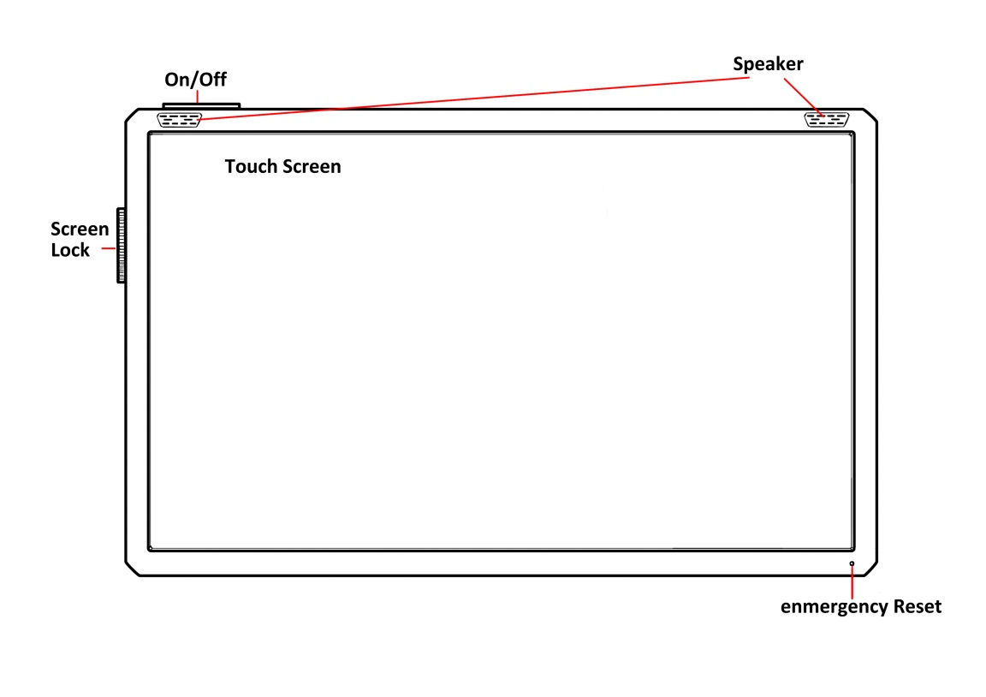

* The main device of our Incar Information System is consisted by a touch screen and some buttons.
* To turn off/on the system, user needs to hold the button at top for a few seconds.
* User can turn on the lock switch to lock the control on touch screen or buttons on main device.
* The device could be hanged in car and need to connect to the car using a USB socket, so that all functions of the device could operate well.

**Side:**

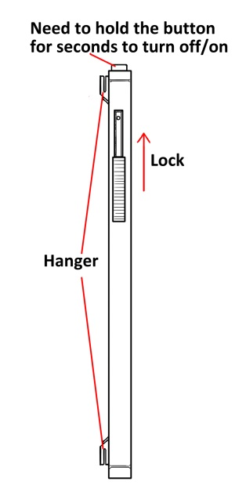

**Bottom:**

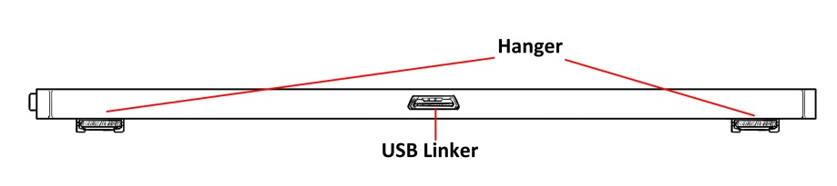

2. Install and Control

The In-car information assistant system IAS-PT-Y could be installed in any cars simply like an interface: User need to hang the device on some place in their car that they feel comfortable. After that, the device needs to be connected to the car use a USB link.

There are also some Bluetooth buttons included with our main device. These buttons could be sticked in any places in car. By pulling these buttons, device would react exactly the same way as user touch a corresponding button on the touch screen. With the help of these buttons, the user could arrange the buttons as their wish and do not need to control on a touch screen while driving. Users could also set the function of each Bluetooth buttons as their wish.

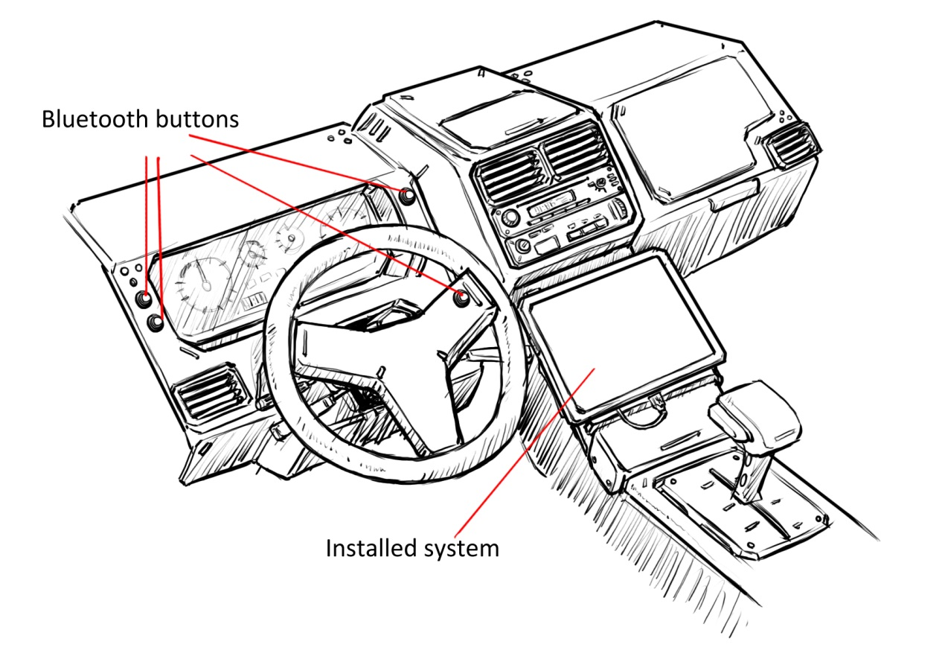

p1.1 Example of properly linked device

The user could also interact with the system by his or her voice. The in-car information assistant system IAS-PT-Y could analyze and distinguish the user’s voice. By saying some keywords such as “IAS routing” or “IAS parking”, user could select the corresponding function without even move his or her hands.

The system would also deliver the driving information by visually method as well as by voice. There are two speakers on the main device and whenever anything updated, system could simply tell the driver what him or her should do.

3. Routing

One of the main functions of our in-car information system is routing. User can set their destination and the system could find the optimal route based on local map saved in device, GPS signal and real-time road condition.  
 To set a destination, the user could either enter the target name on touch screen or simply tell the target by voice.

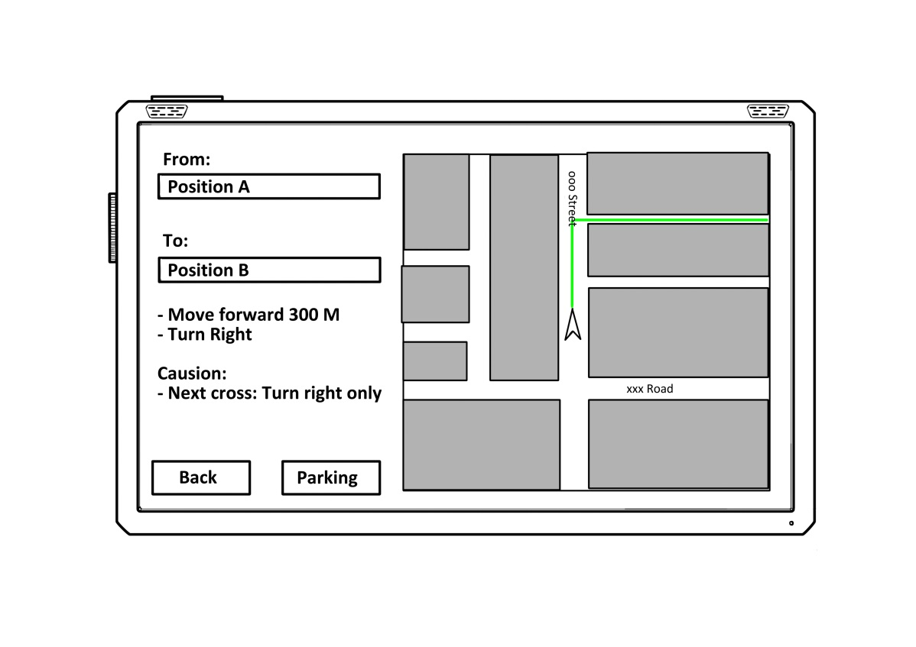

p2.1 The routing view

When the user touch the routing button on touch screen or simply pull the corresponding Bluetooth button, or even says ”IAS routing”, the system would change to routing mode. Under this mode, system would find the optimal route to the target point. While driving, the system would inform driver when and where to do what. It would also notice driver the road conditions such as “turn right only” or “caution for school area”.

If the driver disobeys the system’s suggest and drives into another route, the system would recalculate the route and inform a new optimal route. This optimal route is returned by analyzing real time traffic condition and GPS signal. And thanks to our super powerful algorithm, to find a new route would takes only a feel seconds.

4. Parking

The in-car information assistant system has a powerful parking assistant function. Like routing, user could change the system to parking mode with the same way.

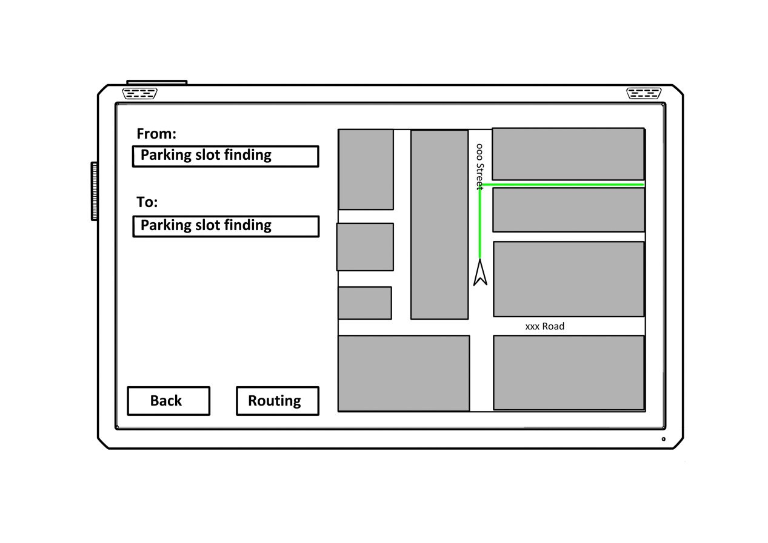

p2.2 The parking view

In parking mode, the system would scan all the nearby parking space, find the nearest one and route to it. After the optimal parking space located, if possible, the system would pre-take up that parking slot in case of other cars parked into that space before the user’s car arrives.

After finished parking, the user could bind his or her cell phone with the system. When the parking space reach its time limit and need to be recharged, the user could finish this work simply using cellphone instead of wasting time by running a long distance away to pay only a few dollars.

5. Setting your own system

The in-car information assistant system IAS-PT-Y allows the user to set their own configuration by themselves. On the main device of the system, user could change basic configurations. For further customized configuration, user needs to connect the main device to a computer. A PC client and detailed helper file are included in the main device. Related information could also be founded in our tech support website: [www.T1004IAS.com/support](http://www.T1004IAS.com/support)

6. Technical Support

To get technical support, you are welcome to visit our tech support website: [www.T1004IAS.com/support](http://www.T1004IAS.com/support)

Or, you can also visit our stores:

<Here is a list of all stores…_(:3_|/_)_...>